**Web Programming**

Lab - 8

Java Script

Name: Sushen Grover

Reg No: 23BCE1728

Slot: L11+L12+L31+L32

Class No: CH2024250502774

Course Code: BCSE203E

Faculty: Dr. L.M. Jenila Livingston

Question 1:



Code:

<!DOCTYPE html>

<html lang="en">

<head>

    <meta charset="UTF-8">

    <meta name="viewport" content="width=device-width, initial-scale=1.0">

    <title>23BCE1728</title>

</head>

<body>

    <h2>Exercise 8.1</h2>

    <p>Prompt and Alert</p>

    <script>

        let a=prompt("Enter first number: ",0);

        let b=prompt("Enter second number: ",0);

        let op=prompt("Enter operator: ",'+');

        let ans=eval(a+op+b);

        alert("Answer: "+ans);

    </script>

</body>

</html>

Output:

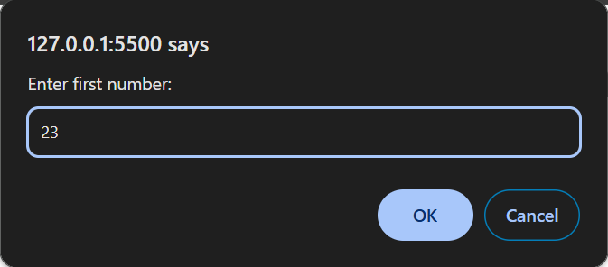

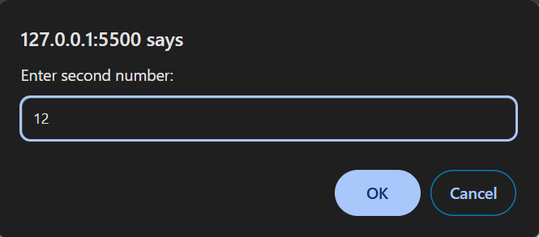

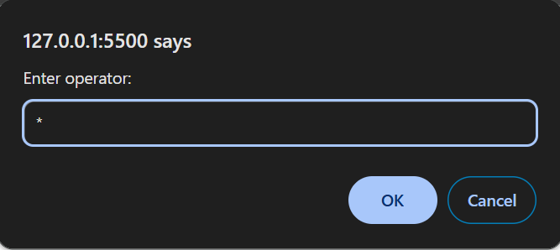

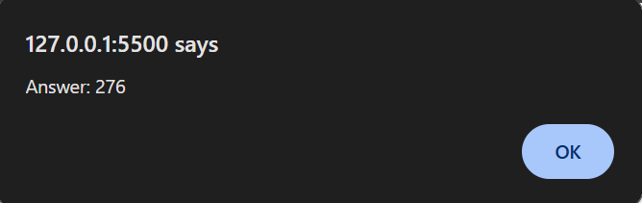

Question 2:



Code:

<!DOCTYPE html>

<html lang="en">

<head>

    <meta charset="UTF-8">

    <meta name="viewport" content="width=device-width, initial-scale=1.0">

    <title>23BCE1728</title>

</head>

<body>

    <h2>Exercise 8.2</h2>

    <p>Prompt and Alert</p>

    <script>

        let age=prompt("Enter your age: ",0);

        if(age>=18){

            alert("You are eligible to drive.");

        }

        else{

            alert("You are not eligible to drive.");

        }

    </script>

</body>

</html>

Output:

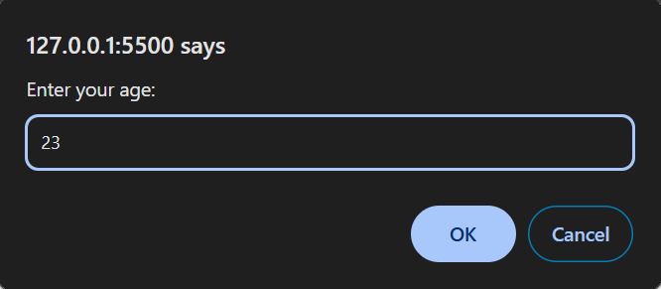

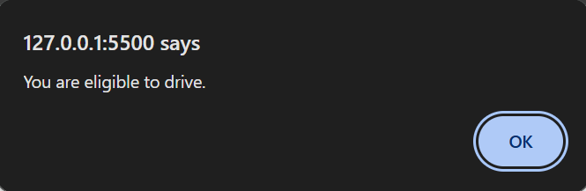

Question 3:



Code:

<!DOCTYPE html>

<html lang="en">

<head>

    <meta charset="UTF-8">

    <meta name="viewport" content="width=device-width, initial-scale=1.0">

    <title>23BCE1728</title>

</head>

<body>

    <H2>Exercise 8.3</H2>

    <form action="">

        <label for="age">Enter your age: </label>

        <input type="text" name="age">

        <br>

        <br>

        <button onclick="check()">Submit</button>

    </form>

    <script>

        function check(){

            confirm("Are you a student?");

        }

    </script>

</body>

</html>

Output:

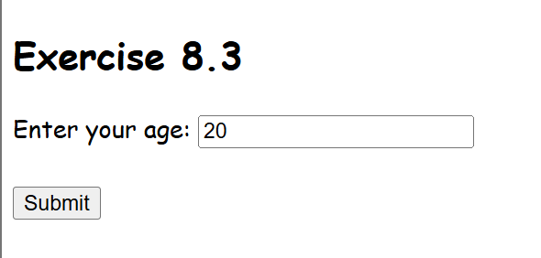

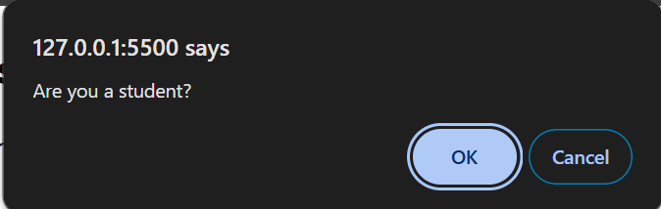

Question 4:

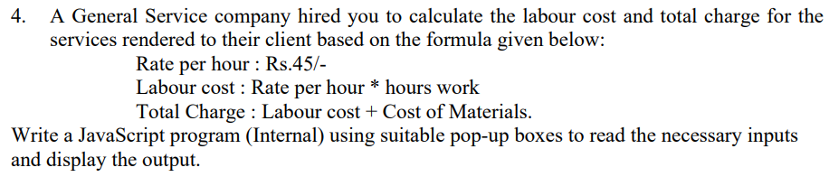

Code:

<!DOCTYPE html>

<html lang="en">

<head>

    <meta charset="UTF-8">

    <meta name="viewport" content="width=device-width, initial-scale=1.0">

    <title>23BCE1728</title>

</head>

<body>

    <h2>Exercise 8.4</h2>

    <p>

        <b>Prompt and Alert</b>

        <br>

        Rate per hour : Rs.45/-

        <br>

        Labour cost : Rate per hour * hours work

        <br>

        Total Charge : Labour cost + Cost of Materials

    </p>

    <script>

        let h=parseInt(prompt("Enter hours worked: ",0));

        let c=parseInt(prompt("Enter cost of materials: ",0));

        let total=(45*h+c);

        alert("Total Charge: "+total);

    </script>

</body>

</html>

Output:

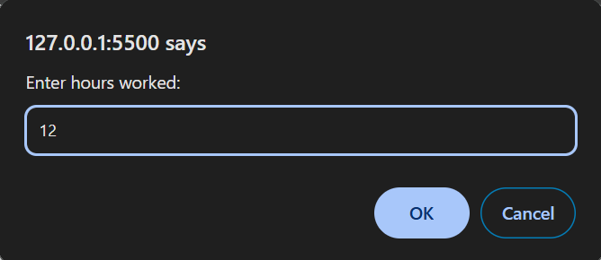

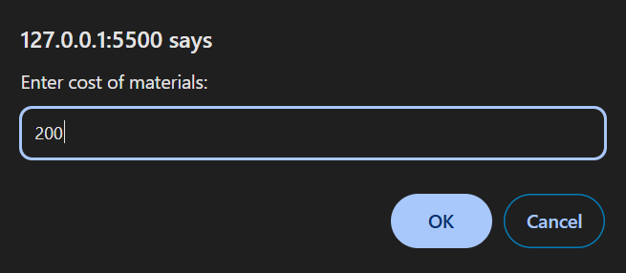

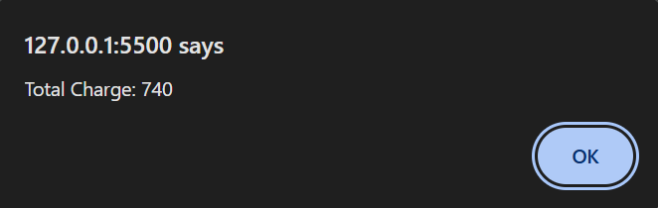

Question 5:

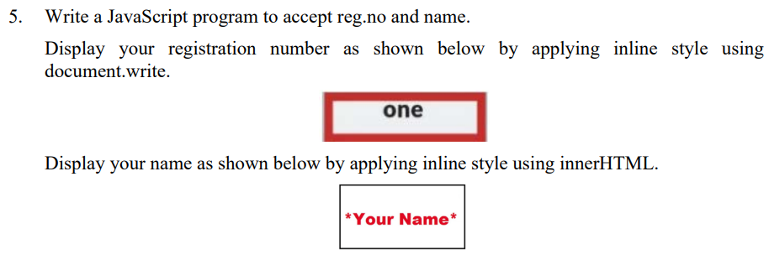

Code:

<!DOCTYPE html>

<html lang="en">

<head>

    <meta charset="UTF-8">

    <meta name="viewport" content="width=device-width, initial-scale=1.0">

    <title>23BCE1728</title>

</head>

<body>

    <H2>Exercise 8.5</H2>

    <form name="f1">

        <label>Reg No:</label>

        <input type="text" name="i1">

        <br>

        <label>Name:</label>

        <input type="text" name="i2">

        <br>

        <button onclick="acceptInput()">Submit</button>

    </form>

    <script>

        function acceptInput(){

            let reg=document.f1.i1.value;

            let name=document.f1.i2.value;

            document.write('<div style="box-sizing:border-box;margin:10px;border: 4px solid red;width:200px;">'+reg+"</div>");

            let element=document.createElement('div');

            element.style.cssText="box-sizing:border-box;margin:10px;color: red;border: 2px solid black;width:200px";

            element.innerHTML=name;

            document.body.appendChild(element);

        }

    </script>

</body>

</html>

Output:

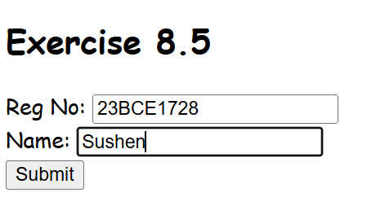

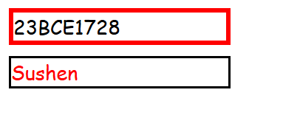

Question 6:

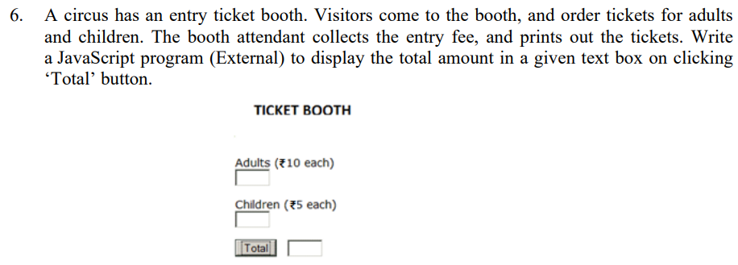

Code:

**HTML**

<!DOCTYPE html>

<html lang="en">

<head>

    <meta charset="UTF-8">

    <meta name="viewport" content="width=device-width, initial-scale=1.0">

    <title>23BCE1728</title>

    <style>

        *{

            padding: 0px;

            margin: 0px;

        }

        .container{

            border: 2px solid black;

            margin: 2px;

            padding: 5px;

            width: 250px;

        }

        .heading{

            text-align: center;

            font-weight: bold;

        }

        .input-div{

            margin: 20px 0px 20px 10px;

        }

        .output-value{

            border: 1px solid black;

            height: 30px;

            width: 80px;

            display: inline-block;

            border-radius: 2px;

        }

        .output-div{

            width: 200px;

            margin: 20px 0px 20px 10px;

            display: flex;

            align-items: center;

            justify-content: space-around;

        }

        button{

            width: 100px;

            height: 30px;

        }

    </style>

</head>

<body>

    <h2>Exercise 8.6</h2>

    <div class="container">

        <div class="heading">TICKET BOOTH</div>

        <div class="input-div">

            <p>Adults (&#8377;10 each)</p>

            <input type="text" id="i1">

        </div>

        <div class="input-div">

            <p>Children (&#8377;5 each)</p>

            <input type="text" id="i2">

        </div>

        <div class="output-div">

            <button onclick="compute()">Total</button>

            <div class="output-value"></div>

        </div>

    </div>

    <script src="script6.js"></script>

</body>

</html>

**JS**

function compute(){

    let e1=document.querySelector('#i1');

    let a=parseInt(e1.value);

    let e2=document.querySelector('#i2');

    let c=parseInt(e2.value);

    let total=(a*10)+(c*5);

    let e3=document.querySelector('.output-value');

    e3.textContent=total;

}

Output:

